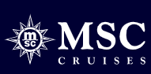
MSC WORLD ATLANTIC NOW OPEN TO BOOK
Sailing from Port Canaveral to the Caribbean winter 2027
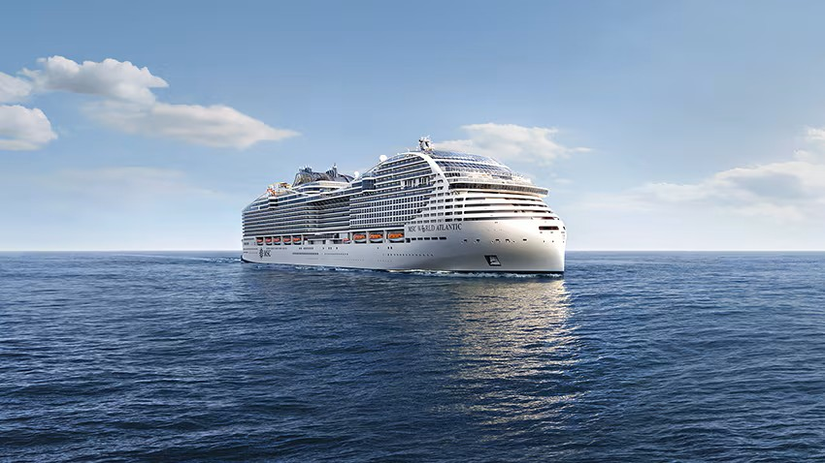
Where Worlds Meet
Introducing MSC World Atlantic, where European style meets American comfort like you've never seen before. Just as the Atlantic connects continents, this ship bridges cultures, flavors, and generations. Go on a global taste tour from authentic Italian cuisine to a sizzling American steakhouse.
Discover spaces where timeless design meets vibrant energy, then dive into sky-high thrills that fill your camera roll.
This isn’t just a cruise. It’s your chance to see, taste, and feel the world in one unforgettable holiday.
Sail on MSC World Atlantic from Port Canaveral to the Caribbean in winter
Now open to book!



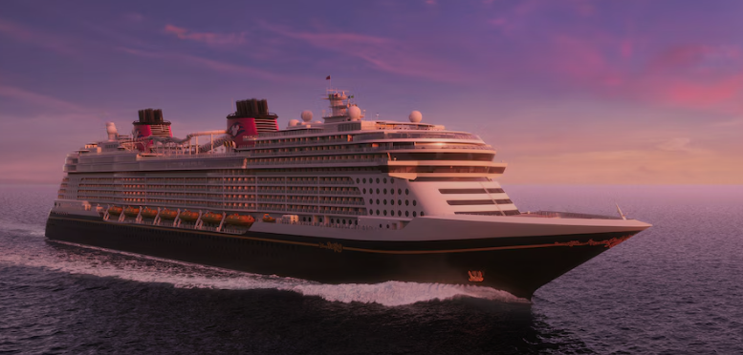
Disney Cruise Line (DCL) offers family-focused, Disney-themed vacations across a growing fleet, known for high-quality entertainment, rotational dining, and exceptional service. With ships like the Disney Wish, Treasure, and upcoming Adventure, they sail to destinations worldwide, including the Caribbean and Asia, featuring characters, fireworks at sea, and tailored experiences for all ages.
Key Features and Offerings:
- Fleet: Includes Disney Magic, Wonder, Dream, Fantasy, Wish, Treasure, and upcoming Adventure and Destiny ships.
- Rotational Dining
Guests rotate through three distinct, themed restaurants while the same servers follow them, ensuring personalized service.
- Entertainment: Broadway-style shows, character meet-and-greets, first-run Disney movies, and, on most sailings, fireworks at sea.
- Family & Adult Fun: Dedicated clubs for kids/teens, plus exclusive areas for adults, including dining and lounges.
- Staterooms: Designed for families, often featuring split bathrooms for efficiency, with significant Disney styling.
Upcoming and New Ships:
- Disney Adventure: The first ship based in Asia, promising unique themed areas like Marvel Landing and Toy Story Place.
- Disney Believe: Announced for a late



Royal Caribbean Cruise
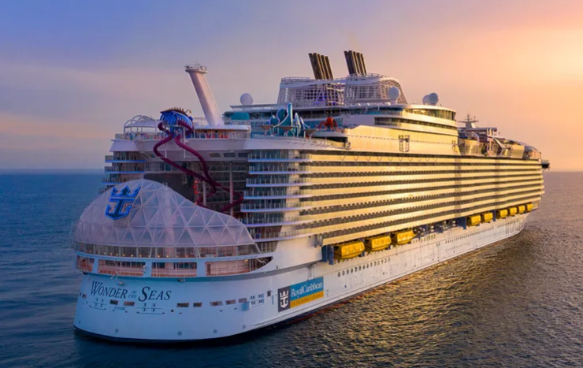
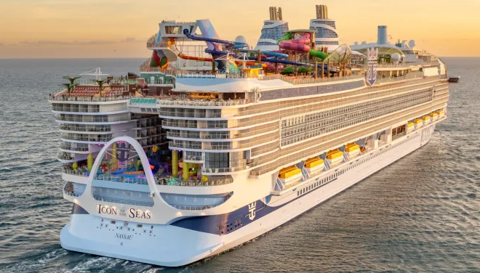
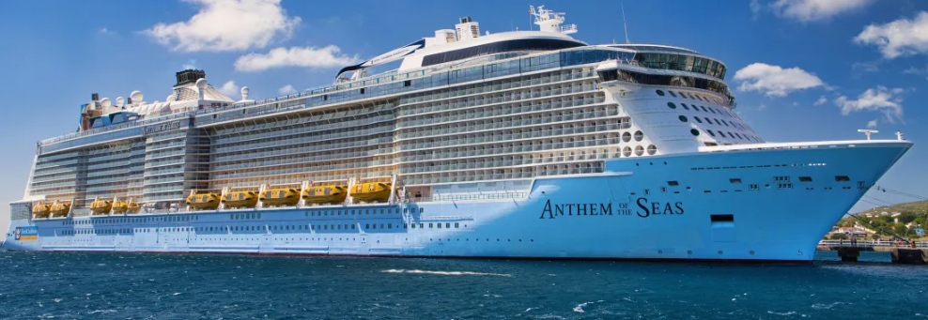
Royal Caribbean International is a premier, Miami-based cruise line founded in 1968, renowned as the world's largest by revenue and a leader in innovative, family-friendly, and adventure-focused vacations. Operating massive, amenity-packed ships—including the record-setting Oasis and Quantum classes—it offers global itineraries with features like surf simulators, skydiving simulators, and Broadway-style entertainment.
Key Highlights of Royal Caribbean International
- Fleet and Class: The fleet is known for its large, amenity-rich vessels, including the Oasis-class (e.g., Wonder of the Seas, Symphony of the Seas) and Quantum-class (e.g., Quantum of the Seas, Odyssey of the Seas) ships.
- Onboard Activities: Known for innovations, features often include FlowRider surf simulators, rock-climbing walls, ice-skating rinks, zip lines, and the RipCord by iFLY simulator.
- Entertainment & Dining: Offers diverse dining options and high-tech entertainment, such as the AquaTheater (aquatic acrobatics) and Two70, a lounge with panoramic ocean views that transforms into an entertainment venue.
- Destinations: Offers both short and long itineraries to worldwide destinations.
- Private Destinations: Features exclusive, high-end private destinations for guests, including Perfect Day at CocoCay in the Bahamas.
- Brand Ownership: Part of the Royal Caribbean Group, which also includes Celebrity Cruises and Silversea.

Cordelia Cruises
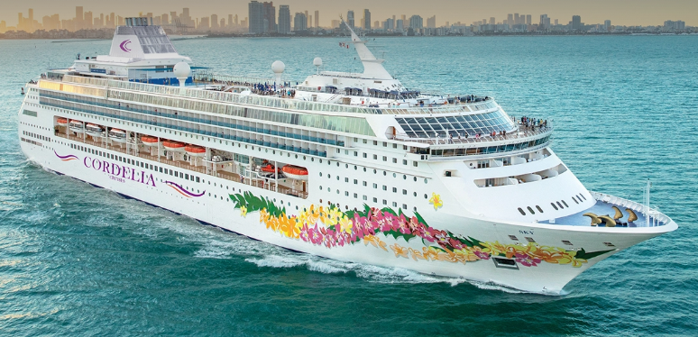
Cordelia Cruises is India’s premier cruise line, offering stylish, luxurious, and Indian-centric, year-round sailings, primarily featuring domestic destinations like Mumbai, Goa, Kochi, Lakshadweep, and Chennai, as well as international routes to Sri Lanka, Malaysia, and Thailand. The fleet, including the flagship Empress, provides curated entertainment, diverse dining, and family-friendly activities.
Key Features and Offerings:
- Fleet & Capacity: The flagship, The Empress, features 11 decks, 796 cabins (Interior, Ocean View, Balcony, Suite), and hosts up to 1,800 guests. New ships, Cordelia Sky and Cordelia Sun, are scheduled for 2026 and 2027.
- Destinations:
  - West Coast (Year-Round): Mumbai, Goa, Kochi, Lakshadweep.
  - East Coast: Chennai, Visakhapatnam, Pondicherry.
  - International: Sri Lanka (Hambantota, Trincomalee, Jaffna), Thailand (Phuket), Singapore, and Malaysia (Kuala Lumpur, Langkawi).
- Onboard Experience: Features include Broadway-style shows, a casino, multiple bars and lounges, a swimming pool, a rock-climbing wall, and a spa.
- Dining: Offers multiple dining venues, including Indian, multi-cuisine, and Jain food options.
- Itinerary Duration: Short 2-night getaways to 5-night extended trips.

Norwegian Cruise Line 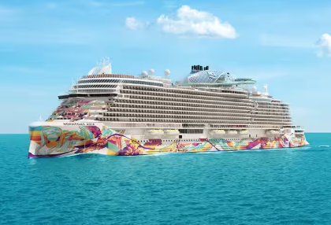
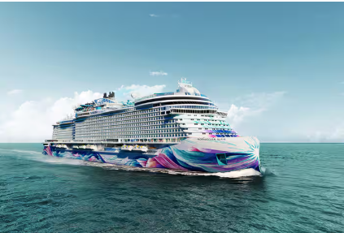
(NCL) is a premier, Miami-based cruise line known for "Freestyle Cruising," which offers no assigned dining times, no formal dress codes, and a casual atmosphere across its ~20-ship fleet. Key features include Broadway entertainment, diverse dining, innovative, modern ships, and dedicated "studio" staterooms for solo travelers. Key Aspects of Norwegian Cruise Line Ships:
Freestyle Cruising: The brand's signature concept emphasizes flexibility, allowing guests to customize their schedule and dining experiences.
Fleet & Classes: NCL operates a diverse fleet (expected to grow to 22+ ships) organized into several classes, including the newer, luxurious Prima class, the large Breakaway and Breakaway Plus classes, the Epic, Jewel class, Dawn class, Sun class, and the Pride of America.
Solo Traveler Focused: NCL is a leader in accommodating solo travelers, offering specialized studio staterooms and a dedicated studio lounge with no single supplement fee.
The Haven: A "ship-within-a-ship" concept providing a luxury boutique hotel experience, featuring private sundecks, exclusive pools, and butler service on larger vessels.
Itineraries: Ships travel to nearly 350 destinations globally, including the Caribbean, Alaska, Europe, Mediterranean, Asia, and Hawaii.
Pride of America: This ship is unique, providing year-round, 7-night, all-American crewed itineraries around the Hawaiian islands.
Amenities: Features frequently include Broadway shows (e.g., Kinky Boots), water parks, adult-only areas (Spice H2O), Mandara Spas, and varied dining, including steakhouse and international options.

